Get rid of the box surrounding the First Name, Last Name, Enter your Email, Enter your Password.

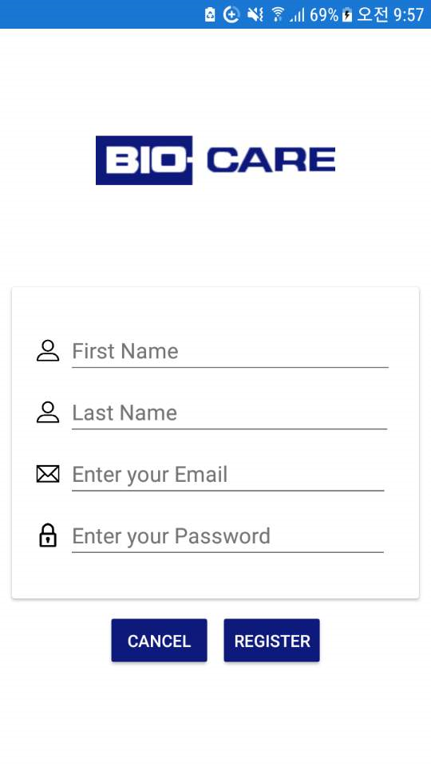

Rep: Have changed it. Please check and share

**Sign In Page**

When user presses the back button, the it should lead the user to the Home Page(where it has the Sign In Button and the Register Button)

* Currently when user presses back button in the Sign in Page, it just quits the app.

Rep: Have changed it. Please check and share